Lab Report – Lab 8

John Notorgiacomo

Data Structures

11/8/2018

Red Black Tree

1. Screenshots demonstrating Left rotation

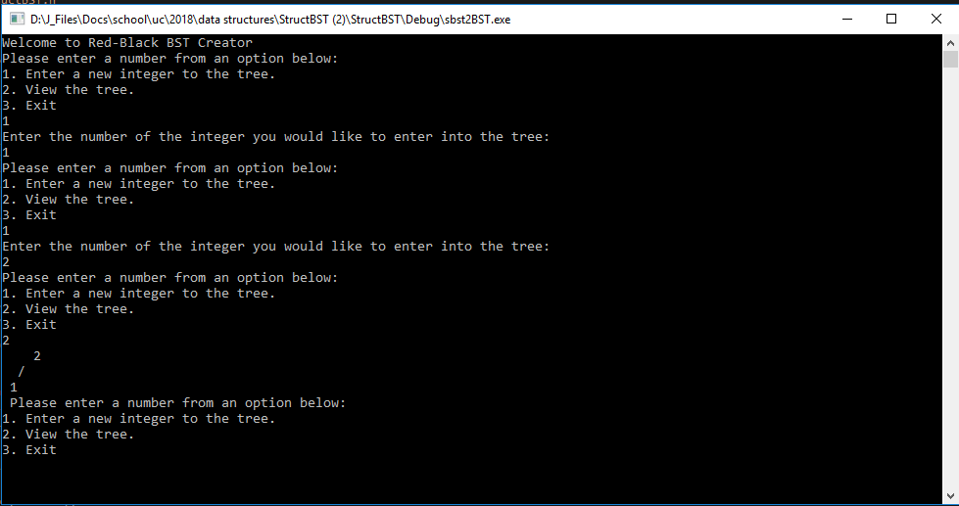

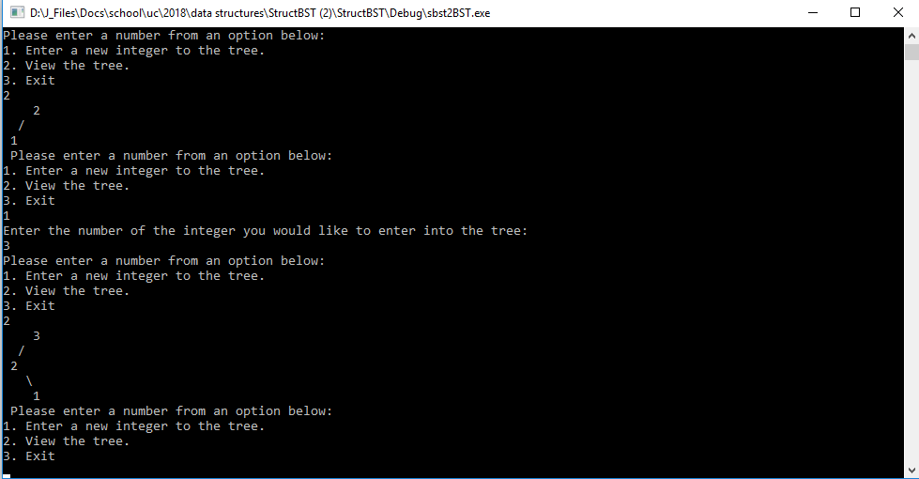

1. Screenshots showing larger scale reorganization – still left

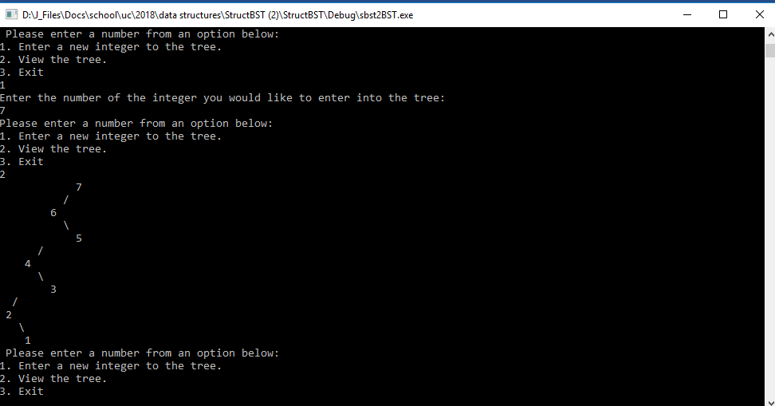

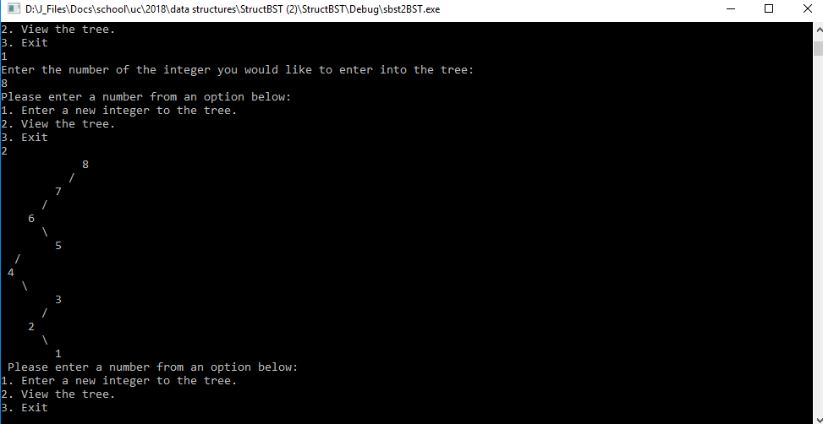

1. Right Rotation

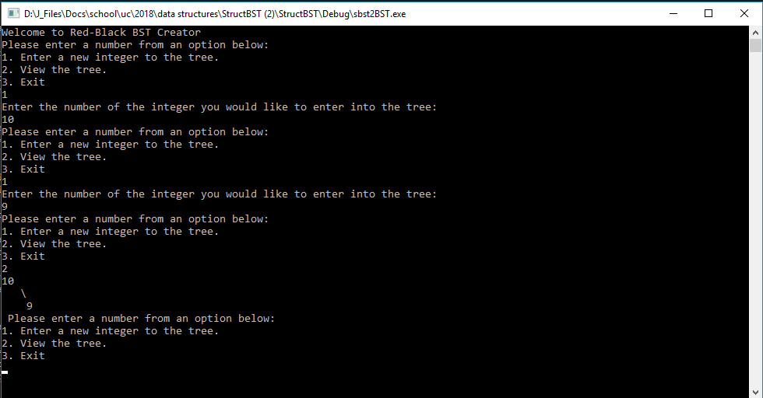

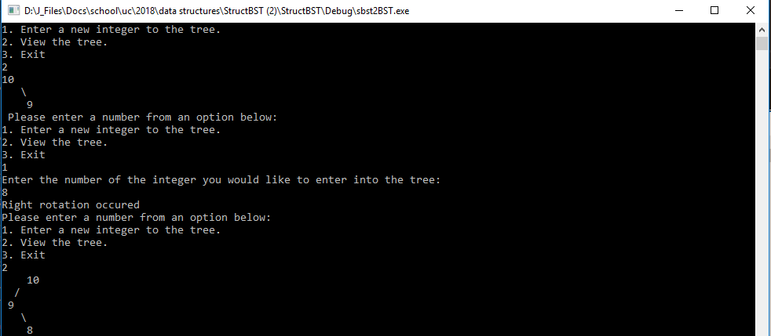

1. Removal not required

Bonus: Notes on debugging – I left a note in my code as well, but I discovered that my cloud8 ide (GCC) was setting the default state of the nodes to be false, red (which was intended). Once I learned how to check that in Visual, I saw that Visual assumed it was supposed to be true, making them all black. This in turn was never fixing the tree inside Visual. I fixed it by simply adding a line in my node constructor specifying that the default color setting should be false in Visual.